# Lab 14: Deep Learning Tutorial 4

By Alex Chang, last modified on 05/30 2020.

## Hardware and Software Setup

Access GPU machine with ssh

**laptop $ ssh [username]@140.113.148.xxx**

Type the password then you will see like this

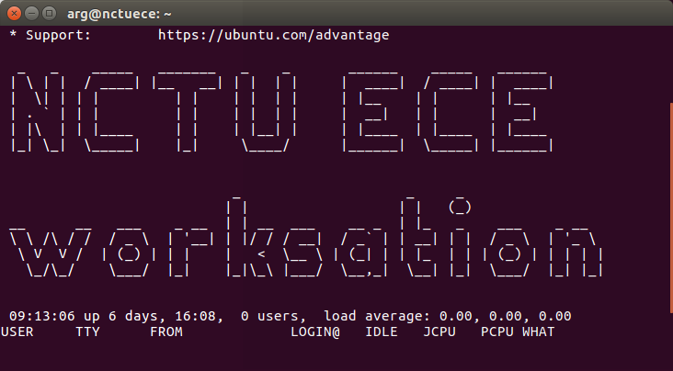-

**ws : workstation**

Clone the course repository

**ws $ cd  
ws $  
git clone** [**https://github.com/Sensing-Intelligent-System/sis_lab_all_2020**](https://github.com/Sensing-Intelligent-System/sis_lab_all_2020) **-b [your_branch]**

**ws $ cd sis_lab_all_2020 && git pull origin master**

Run the docker and jupyter notebook

**ws $ cd 14-Deep_Learning_4/ && source docker_run.sh**

**container $cd sis_lab_all_2020/14-Deep_Learning_4/**

**container $ source jupyter_no_broswer.sh**

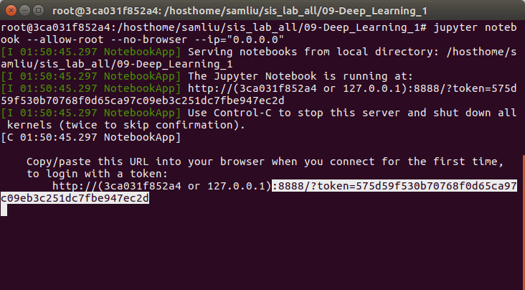

e.g. http://**[workstation_ip]**:**[port]**?token=**[xxxxx]**

Turn on the web browser on local and type the **workstation’s IP** and **token** from above

You will see something like this

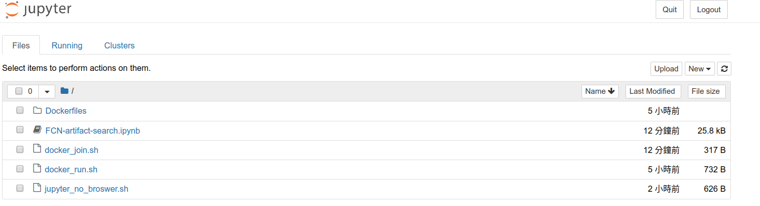

**Lab 14: Deep Learning Tutorial 4** **1**

Hardware and Software Setup 1

Overview 2

Topics and Activities 3

Topic 1 Pytorch-FCN 3

Assignment Tasks 4

Reference 4

## Overview

Estimated Time to Finish: 1 hour

After completing this tutorial you should

* Know the complete process to load, train data, and evaluate your model with test data.
* Understand how to use the Jupyter notebook.
* Understand how FCN works

## Topics and Activities

### Topic 1 Pytorch-FCN

**Note :** Load pre-trained model from google drive first. ‘gdown’ is a tool let user download file from google drive directly.

When turn on jupyter notebook, and click **FCN-artifact-search.ipynb**

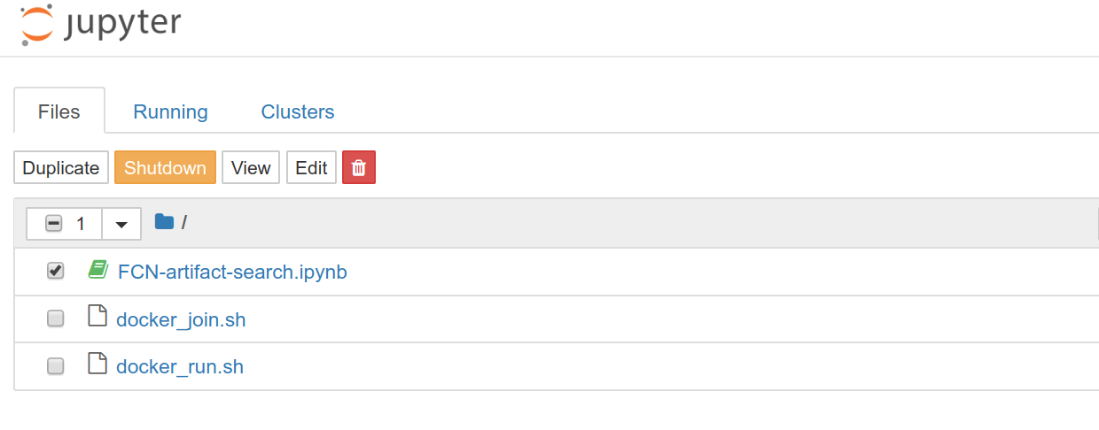

**After training for subt_dataset, you can use this method to finish final project task-1.**

**Discussion.**

1. **Show the prediction result and loss, iou data**
2. **If we want to design FCN8s, how to revise the structure?**
3. **Could you elaborate on how does dataloader load data and preprocess image?**

## 

## Assignment Tasks

Students should do this by themselves and show the result to TA.

Use classroom concepts to design a FCN8s model.

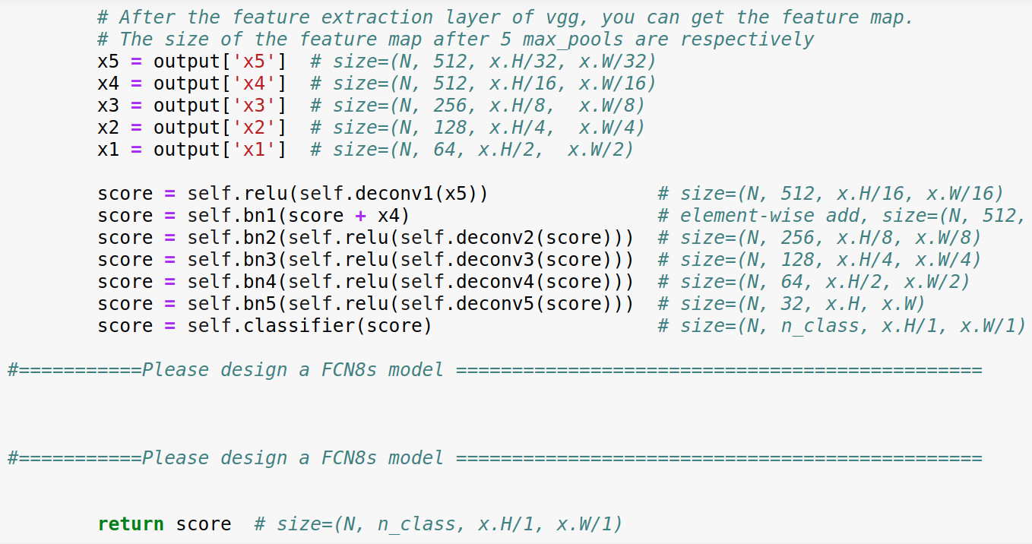

## Reference

Pytorch official tutorial: <https://pytorch.org/tutorials/>

Mila-udem pytorch tutorial: <https://github.com/mila-udem/welcome_tutorials/tree/master/pytorch>

Pytorch-FCN:

<https://github.com/wkentaro/pytorch-fcn>

<https://github.com/pochih/FCN-pytorch/blob/master/python/train.py>